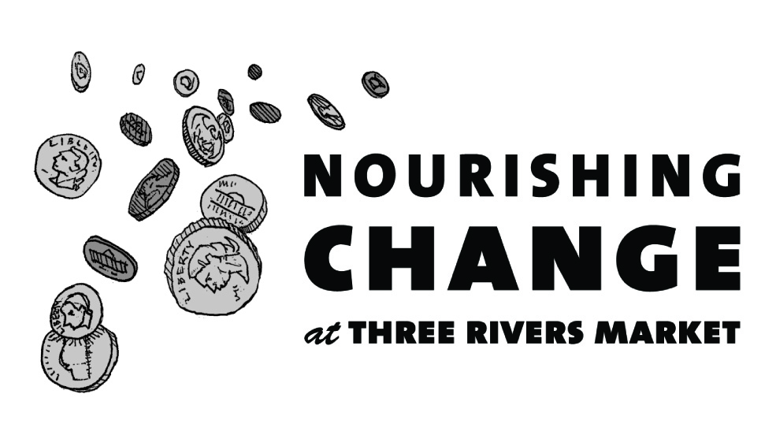
Announcing how we'll be Nourishing Change in our community in the next 6 months!

In July, we will be collecting change to give people with disabilities access to adaptive sports
- Objective: To raise $7,000 to provide a van to transport adaptive mountain bikes to expand activities and allow access to more than just greenways
- Partner: Catalyst Sports Knoxville

Catalyst Sports Knoxville provides people with disabilities the life changing opportunity to access adaptive sports. They provide outdoor recreation and sports opportunities for children and adults with physical disabilities in the greater Knoxville area. Some of their activity clinics include kayaking, mountain biking, and rock climbing.

In August, we will be collecting change to provide home delivered meals and financial assistance for cancer patients and their families during treatment
- Objective: To raise $7,000 to support their Caring Plate program serving meals and providing supplements
- Partner: Provision CARES Foundation

Provision CARES Foundation is a public charity whose mission is to provide wellness, education, and treatment assistance for cancer patients and their families in East Tennessee. Their three primary focus areas include inspiring health, clinical research, and patient assistance.

In September, we will be collecting change to teach healthy habits to Latino children in Knox County school programs
- Objective: To raise $7,000 to purchase cooking utensils and healthy ingredients for children to use while learning to make foods they enjoy
- Partner: Centro Hispano de East Tennessee

Centro de Hispano works in Knoxville area schools to offer after school programming to Latino youth. Hispanic children are 41% more likely to be obese and much more likely to develop early onset diabetes than their white peers. Funds will be used for fun, educational afterschool cooking classes.

In October, we will be collecting change to save and change lives of those impacted by domestic violence through education, prevention and education
- Objective: To raise $7,000 to provide domestic violence support groups, outreach services, and shelter for clients
- Partner: Haven House

Haven House is a domestic violence shelter that provides wrap-around services to victims and survivors of domestic violence 24/7, 365. All services are confidential and at no cost.

In November, we will be collecting change for youth ages 18-24 who are experiencing homelessness
- Objective: To raise $7,000 to provide a peer network, employment, education opportunities, and housing
- Partner: CAC Youth WINS (When In Need of Service)

Youth WINS and its Youth Action Board provide our local homeless and housing-insecure youth with a voice to address the very unique struggles they have in finding permanent housing. They assist with housing, school, transportation, job assistance and coaching, vital documents (ID’s, etc.), seeing a doctor, and sobriety and mental health.

In December, we will be collecting change to expand access to bicycles in Knoxville
- Objective: To raise $7,000 to repair and donate bikes and employ youth to provide job training and career skills
- Partner: Two Bikes

Two Bikes is expanding access to bicycles in Knoxville by providing access to affordable bicycles, free community work benches, hosting donation-based bicycle education classes, and by pledging to give away half their bikes for free. They help community members and keep bikes out of landfills.

Over the past 6 months we received applications from a wide variety of organizations doing important work for our community. If your application was not selected, we strongly encourage you to re-apply. Past recipients are eligible to re-apply as well.

If your application is unclear or incomplete it cannot be considered, so please take care.

To discuss tips on creating a successful Nourishing Change application, please contact Betsy Payne at b.payne@threeriversmarket.coop. For more information, visit http://www.threeriversmarket.coop/about-three-rivers-market/nourishing-change/

