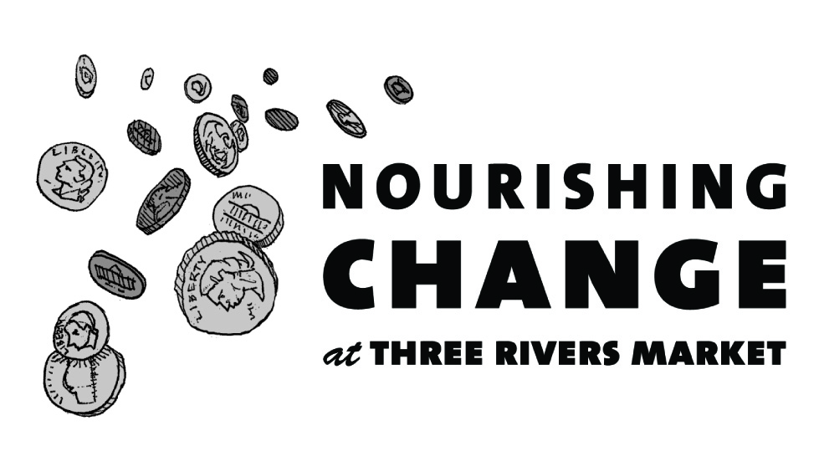
Announcing how we'll be Nourishing Change in our community in the next 6 months!

In July, we will be collecting change to rescue injured or orphaned wildlife
- Objective: To raise $7,000 to rehabilitate wildlife mammals and reintroduce them to their native environment whenever possible
- Partner: Mountain Tails Wildlife Rehab

Mountain Tails Wildlife Rehab rescues and rehabilitates wildlife through its Tennessee Wildlife Resources Agency (TWRA) authorized program, helping to ensure the survival of keystone species. This creates the conditions that support wetland areas that help clean water and promote sustainable environment for an assortment of other wildlife.

In August, we will be collecting change to help every child in our community become a proficient reader
- Objective: To raise $7,000 to provide 1,400 low-income children with a new book, literacy activities and supplies, and parent resources
- Partner: Friends of Literacy

Friends of Literacy’s “Literacy to Go” program nurtures literacy in the home, raising the reading levels of at-risk children. Low literacy skills are directly linked to greater inequality, higher unemployment, less income, and poor health.

In September, we will be collecting change to provide medical services for homeless cats
- Objective: To raise $7,000 to provide spay/neuter services and vaccinations to prepare feral cats for adoption
- Partner: Feral Feline Friends

Feral Feline Friends is an all-volunteer organization with a mission to end the overpopulation of cast in the East Tennessee area, protect the welfare of cats, and promote the humane treatment and well-being of these animals.

In October, we will be collecting change to provide free food to the hungry
- Objective: To raise $7,000 to support expansion of the food pantry
- Partner: The Pellissippi Pantry

The Pellissippi Pantry provides free food to Pellissippi State students and employees experiencing food insecurity. The Pantry is expanding from 115 square feet to 3000 square feet. Funds will help outfit it with necessary equipment. The Pantry supplements packaged foods with fresh produce, herbs, and fruit from its ¾ acre organic garden adjacent to The Pantry.

In November, we will be collecting change to transport East Tennessee shelter animals to large modern shelters where animal are adopted quickly
- Objective: To raise $7,000 to replace the primary transport vehicle
- Partner: GoNorth Animal Transport Collaborative

Operated by all-volunteer non-profit organization Peaceful Kingdom, the GoNorth Animal Transport Collaborative is a group of overcrowded East Tennessee animal shelters that transports animals to shelters with high adoption demand to eliminate euthanasia for space in participating shelters. Over 18,500 shelter animals in 15 East Tennessee counties have gotten a 2nd chance at life through this program.

In December, we will be collecting change to ensure low-income seniors can keep their pets
- Objective: To raise $7,000 for food and medical expenses
- Partner: KnoxPAWS (Placing Animals With Seniors)

Knox PAWS, a program of Knoxville-Knox County Community Action Committee (CAC) Office on Aging, helps eligible seniors adopt homeless animals and to keep their pets by providing food and medical services. Having a pet reduces loneliness and stress, lowers blood pressure, and improves physical and mental well-being.

Over the past 6 months we received 21 applications from organizations doing important work for our community. A majority of our applications in this round were in support of homeless and/or abandoned animals. If your application was not selected, we strongly encourage you to re-apply. Past recipients are eligible to re-apply as well.

If your application is unclear or incomplete it cannot be considered, so please take care.

To discuss tips on creating a successful Nourishing Change application, please contact Jacqueline Arthur, General Manager at j.arthur@threeriversmarket.coop. For more information, visit http://www.threeriversmarket.coop/about-three-rivers-market/nourishing-change/

