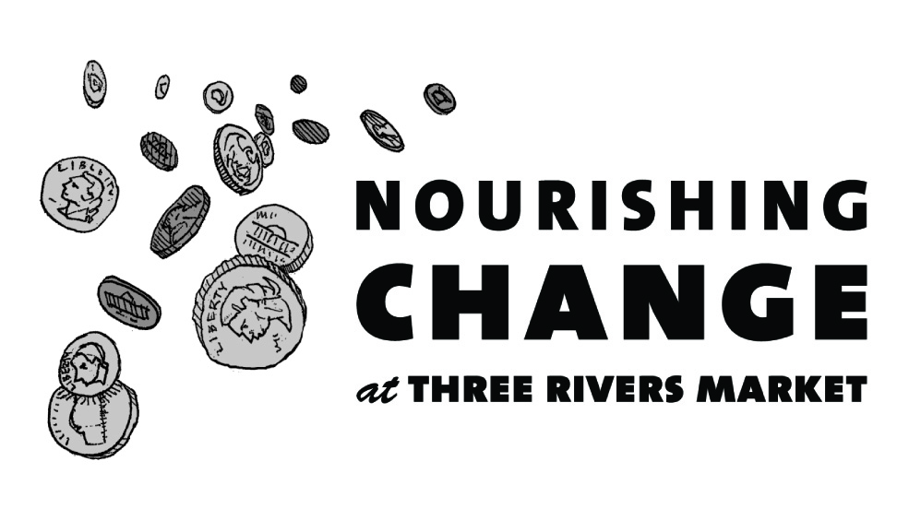
Announcing how we'll be Nourishing Change in our community in the next 6 months!

In July, we will be collecting change to give food to the hungry
- Objective: To raise $7,000 to provide free groceries to feed 1,400 families of four.
- Partner: The Northwest FISH Hospitality Pantry

The Northwest FISH Hospitality Pantry provides nearly 4,000 food packages each month to families needing food assistance. Throughout the COVID-19 pandemic they have been serving 200 additional families per week as well as providing over 5,000 pounds of food to neighboring immigrant communities. They provide the most nutritious foods possible in a respectful, non-judgmental way.

In August, we will be collecting change to provide free medical care for homeless, abandoned, and abused cats
- Objective: To raise $7,000 to provide medical treatment for sick and injured cats in need of a home
- Partner: Happy Paws Kitten Rescue

Happy Paws Kitten Rescue focuses on rescuing cats from high kill rural shelters across East Tennessee, providing medical care and support for adoption, as well as homeless cats in our community.

In September, we will be collecting change to provide assisted transportation for people in need
- Objective: To raise $7,000 to provide affordable, specialized transportation for seniors and people with disabilities
- Partner: Volunteer Assisted Transportation

Volunteer Assisted Transportation, a program of Knoxville-Knox County CAC, provides affordable rides to people in need of aid and assistance to travel safely. Volunteers provide rides in energy-efficient hybrid vehicles to grocery stores, pharmacies, and even the VA hospital in Johnson City, TN.

In October, we will be collecting change to support LGBTQQ youth
- Objective: To raise $7,000 for adult mentors to fight against bullying, social isolation, and rejection of vulnerable East Tennessee youth.
- Partner: Big Brothers Big Sisters of East Tennessee

Big Brothers, Big Sisters of East Tennessee has been defending the lives of children since 1970, serving this area’s most vulnerable youth using expertise fine-tuned by Big Brothers Big Sisters of America for more than a century.

In November, we will be collecting change to provide medical care to homeless animals
- Objective: To raise $7,000 to provide vaccinations, spay/neuter surgeries, and emergency medical care to animals at the Blount County Animal Center
- Partner: Smoky Mountain Animal Care Foundation

The Smoky Mountain Animal Care Foundation ensures that shelter animals receive veterinary care, maximizing adoptions and providing hospice care when necessary.

In December, we will be collecting change to support seniors who are cognitively impaired
- Objective: To raise $7,000 for a safe, structured day program for older adults with some form of dementia or frailty
- Partner: The Daily Living Center

The Daily Living Center, a program of Knoxville-Knox County CAC, provides licensed community-based services to allow the person to remain in the community. The goals of the program including preventing or delaying nursing home placement, preventing or alleviating elder abuse and neglect, and ensuring basic nutrition.

Over the past 6 months we received 20 applications from a wide variety of organizations doing important work for our community. If your application was not selected, we strongly encourage you to re-apply. Past recipients are eligible to re-apply as well.

If your application is unclear or incomplete it cannot be considered, so please take care.

To discuss tips on creating a successful Nourishing Change application, please contact Jacqueline Arthur, General Manager at j.arthur@threeriversmarket.coop. For more information, visit http://www.threeriversmarket.coop/about-three-rivers-market/nourishing-change/

