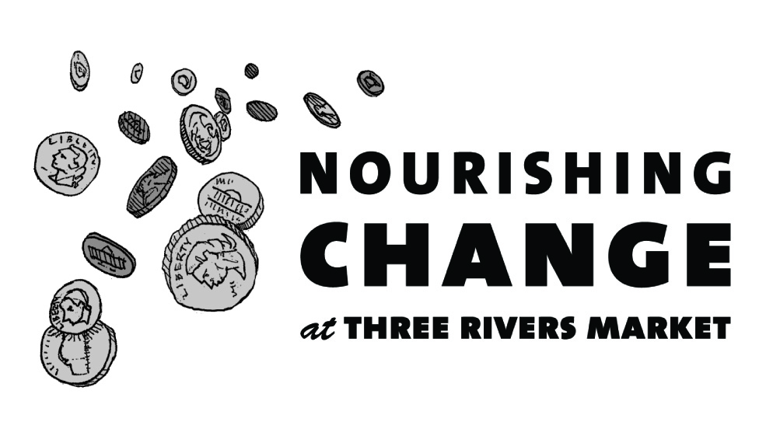
Announcing how we'll be Nourishing Change in our community in the next 6 months!

In January, we will be collecting change to give food to the hungry
- Objective: To raise $7,000 to provide hot meals and basic necessities to the homeless and marginalized in our community
- Partner: A Place at the Table

A Place at the Table provides hot meals to over 200 people each week. They strive to enhance the self-worth and dignity of those they serve by providing basic needs of food, water, simple necessities, and clothing. Their goal is to assuage hunger - making a difference, one meal at a time.

In February, we will be collecting change to improve access to healthy, fresh food to those in need
- Objective: To raise $7,000 to provide basic supplies for a community gardening program for refugees
- Partner: Bridge Refugee Services

Bridge Refugee Services provides opportunities for refugees to rebuild their lives after suffering persecution, so they can become productive and contributing members of our community. The Community Gardening Program helps refugees to grow their own food and participate in local food entrepreneurship.

In March, we will be collecting change to provide care for pets living in poverty
- Objective: To raise $7,000 to provide free, basic veterinary care for the pets of the homeless and working poor
- Partner: Companion Animal Initiative of Tennessee

Companion Animal Initiative of Tennessee improves the lives of companion animals by addressing animal welfare issues, including providing spay/neuter surgeries, vaccines, parasite preventatives, and supplies to the homeless through the College of Veterinary Medicine at the University of Tennessee.

In April, we will be collecting change to support young adults with cognitive disabilities
- Objective: To raise $7,000 for seeds and other supplies for young adults with cognitive disabilities to grow and sell fresh herbs
- Partner: Special Growers

Special Growers develops programs that offer employment and vocational training to young adults with cognitive disabilities who produce and distribute fresh herbs to specialty restaurants in Blount and Knox Counties.

In May, we will be collecting change to assist African American youth with reading and computing
- Objective: To raise $7,000 to supply educational supplies and computer equipment to STEAMI Summer Institute participants.
- Partner: UUNIK Academy

UUNIK Academy assists in the holistic development of African-American youth in order to become responsible adults. The STEAMI (Science, Technology, Engineering, Arts, and Mathematics Innovation) Summer Institute is an annual 7-week program dedicated to the academic enrichment of African-American males, ages 5 to 10 years.

In June, we will be collecting change to provide healthy food options for children
- Objective: To raise $7,000 to feed children cared for by East TN’s only non-profit, extended hours childcare center
- Partner: The Blossom Center for Childhood Excellence

The Blossom Center is a unique non-profit organization, providing affordable and accessible child care through a sliding scale, income based tuition schedule and 20 hours/day, 7 days/week services, and emergency services for families in crisis.

Over the past 6 months we received 26 applications from a wide variety of organizations doing important work for our community. If your application was not selected, we strongly encourage you to re-apply. Past recipients are eligible to re-apply as well.

If your application is unclear or incomplete it cannot be considered, so please take care.

To discuss tips on creating a successful Nourishing Change application, please contact Jacqueline Arthur, General Manager at j.arthur@threeriversmarket.coop. For more information, visit http://www.threeriversmarket.coop/about-three-rivers-market/nourishing-change/

