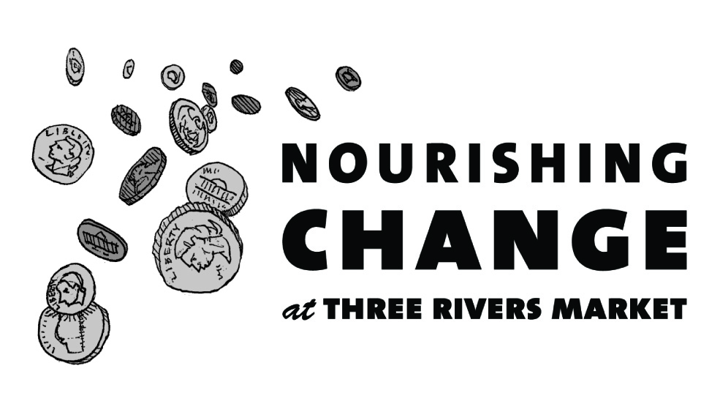
Announcing how we'll be Nourishing Change in our community in the next 6 months!

In July, we will be collecting change to give food to the hungry
- Objective: To raise $7,000 to provide free meals to people in need.
- Partner: The Love Kitchen
The Love Kitchen provides meals, clothing and emergency food packages to homebound, homeless and unemployed people of all races and faiths. Their goal is to provide nourishment for anyone who is hungry and to establish a community center to serve as a haven supporting area children and their families.

In August, we will be collecting change to improve the health of children and their families
- Objective: To raise $7,000 to support holistic health and nutrition programs for children and adults in Knoxville’s Latino community.
- Partner: Centro Hispano de East Tennessee
Centro Hispano de East Tennessee is the cultural and educational hub for the Latino community in East Tennessee, helping families to integrate and thrive culturally, educationally, and economically.

In September, we will be collecting change for environmental restoration
- Objective: To raise $7,000 to plant a wildlife demonstration garden using native plants to attract birds, butterflies, bees, bats, and other pollinators at Seven Islands State Birding Park
- Partner: Friends of Seven Islands
Seven Islands State Birding Park vision is to become a world class birding destination, to protect, preserve and promote its natural resources, and to educate the public. This wildlife garden will inspire park guests to plant their own gardens to support pollinators.

In October, we will be collecting change to save the lives of abused women and children
- Objective: To raise $7,000 to provide abused women and children with safety and emergency needs
- Partner: Knoxville Family Justice Center
Domestic violence is a public safety threat in our community. Police in Knox County respond to a domestic violence call every 30 minutes. Funds will be used to change locks, purchase bus tickets or gas vouchers for transportation, gift cards for groceries, hotels when shelters are full, or translation services for non-English speaking victims.

In November, we will be collecting change to give food to the hungry
- Objective: To raise $7,000 to provide 3 days’ worth of food for 1,400 families
- Partner: The South Knoxville FISH Hospitality Pantry
The South Knoxville FISH Hospitality Pantry currently provides food packages to more than 2,000 families each month in a non-judgmental way that respects their dignity and privacy. Diversity is celebrated at the Pantry and everyone is welcomed.

In December, we will be collecting change to save sick and injured homeless animals in need
- Objective: To raise $7,000 to provide medical treatment for animals so they can find a home
- Partner: Young-Williams Animal Center
The Young-Williams Animal Center Compassion Fund provide medical care to animals coming to the shelter sick or injured, providing surgical or medical treatment for hernias, eye injuries, tumors, dental disease, broken bones, infections, and countless other conditions.

Over the past 6 months we received 24 applications from a wide variety of organizations doing important work for our community. If your application was not selected, we strongly encourage you to re-apply. Past recipients are eligible to re-apply as well.

If your application is unclear or incomplete it cannot be considered, so please take care.

To discuss tips on creating a successful Nourishing Change application, please contact Jacqueline Arthur, General Manager at j.arthur@threeriversmarket.coop. For more information, visit http://www.threeriversmarket.coop/about-three-rivers-market/nourishing-change/

